**Assignment:**

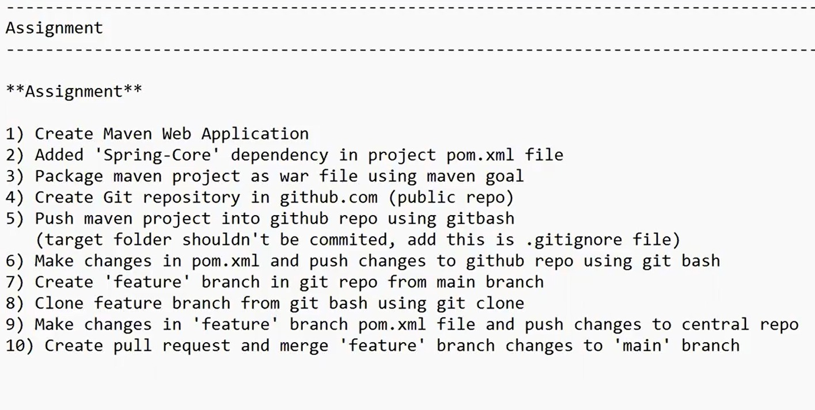

1. **Create a Maven Application**

mvn archetype:generate -DarchetypeArtifactId=maven-archetype-webapp -DartifactId=assignment -DgroupId=assignment.com -DarchetypeGroupId=org.apache.maven.archetypes -DarchetypeGroupId=org.apache.maven.archetypes -DinteractiveMode=false

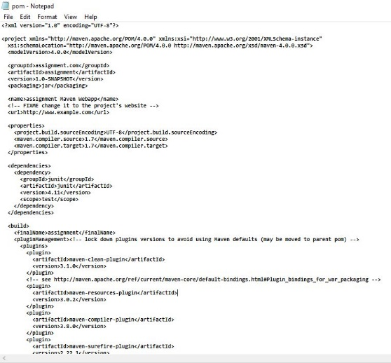

1. **Adding 'spring-core' dependency in project pom.xml file**

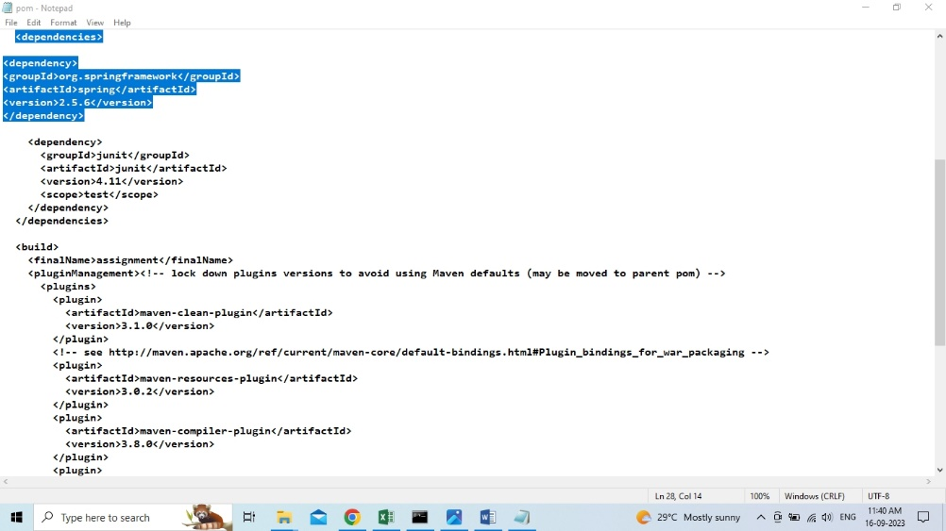

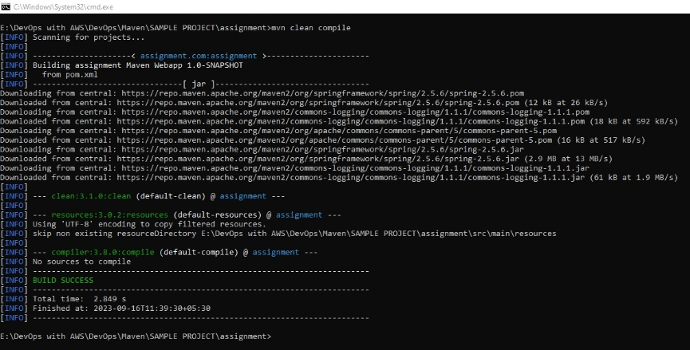

1. **Package maven project as war file using maven goal**

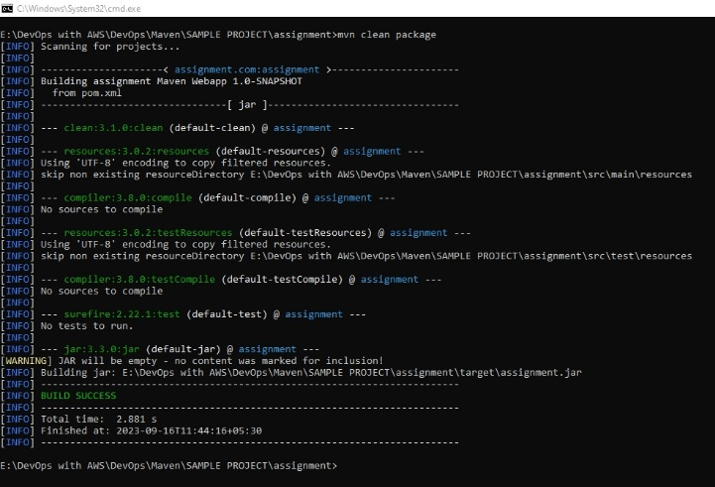

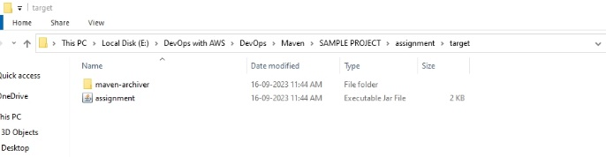

1. **Created git repository in github (public repo).**

https://github.com/rbasha786/assignement-git-maven.git

1. **Push maven project into github repo using gitbash**

**(target folder should't be commited, add this is .gitignore file)**

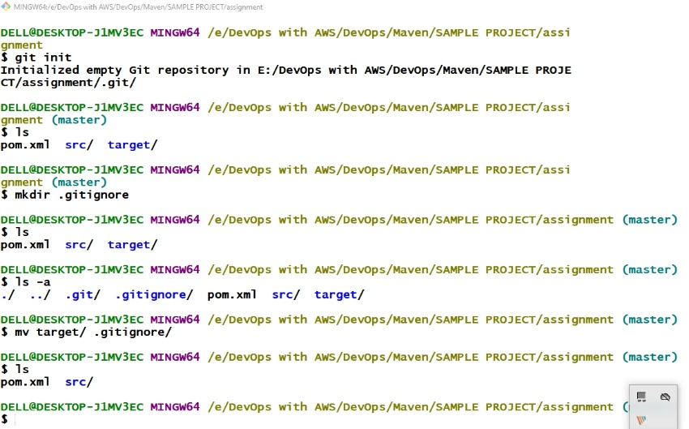

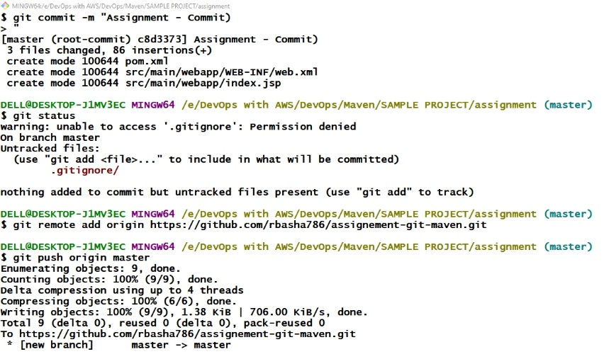

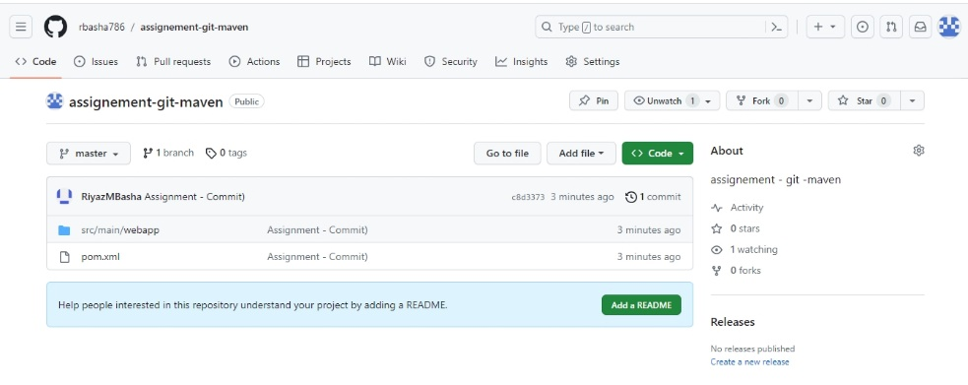

1. **Make changes in pom.xml and push chage to github repo using git bash**

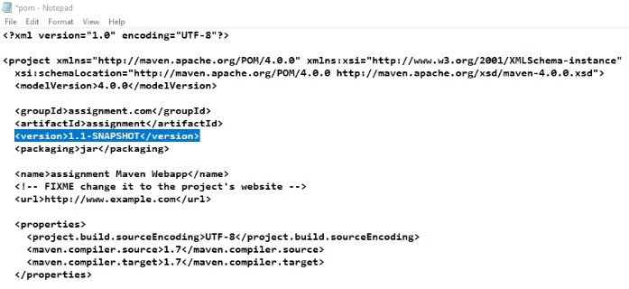

**Note: Changed the version from 1.0 to 1.1**

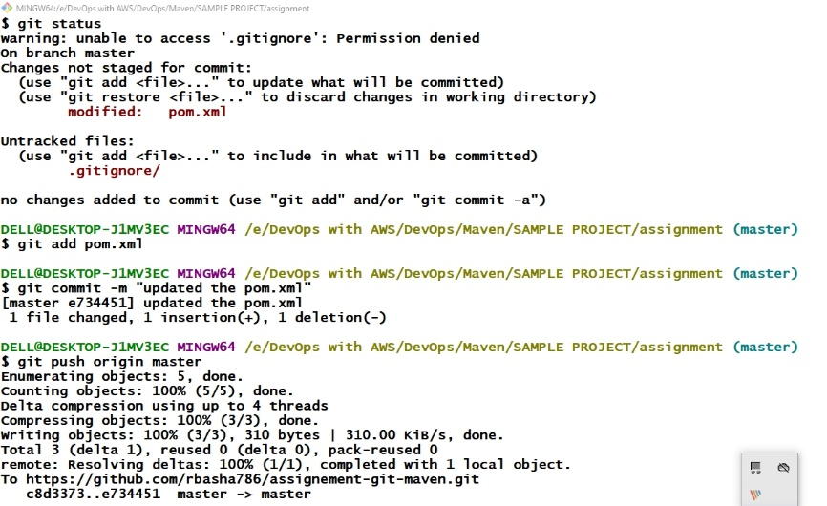

**7. Create ‘feature’ branch in git repo from main branch and also**

**8. Cloned feature branch from git bash using git clone**

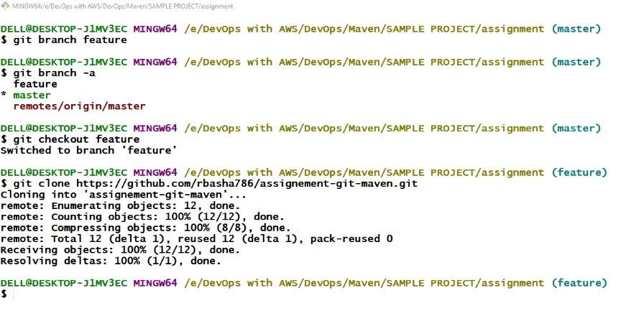

**9) Make changes in “feature” branch pom.xml file and push changes to central repo.**

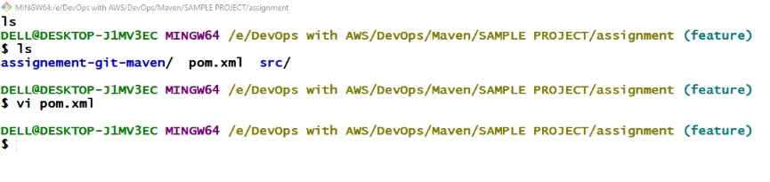

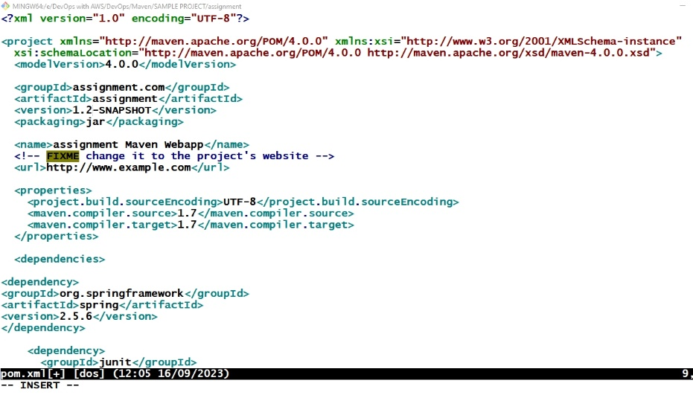

DELL@DESKTOP-J1MV3EC MINGW64 /e/DevOps with AWS/DevOps/Maven/SAMPLE PROJECT/assignment (feature)

$ git commit -m "Changed version 1.2 in pom.xml"

[feature 7cba163] Changed version 1.2 in pom.xml

1 file changed, 1 insertion(+), 1 deletion(-)

DELL@DESKTOP-J1MV3EC MINGW64 /e/DevOps with AWS/DevOps/Maven/SAMPLE PROJECT/assignment (feature)

$ git push origin feature

Enumerating objects: 5, done.

Counting objects: 100% (5/5), done.

Delta compression using up to 4 threads

Compressing objects: 100% (3/3), done.

Writing objects: 100% (3/3), 318 bytes | 318.00 KiB/s, done.

Total 3 (delta 1), reused 0 (delta 0), pack-reused 0

remote: Resolving deltas: 100% (1/1), completed with 1 local object.

remote:

remote: Create a pull request for 'feature' on GitHub by visiting:

remote: https://github.com/rbasha786/assignement-git-maven/pull/new/feature

remote:

To https://github.com/rbasha786/assignement-git-maven.git

* [new branch] feature -> feature

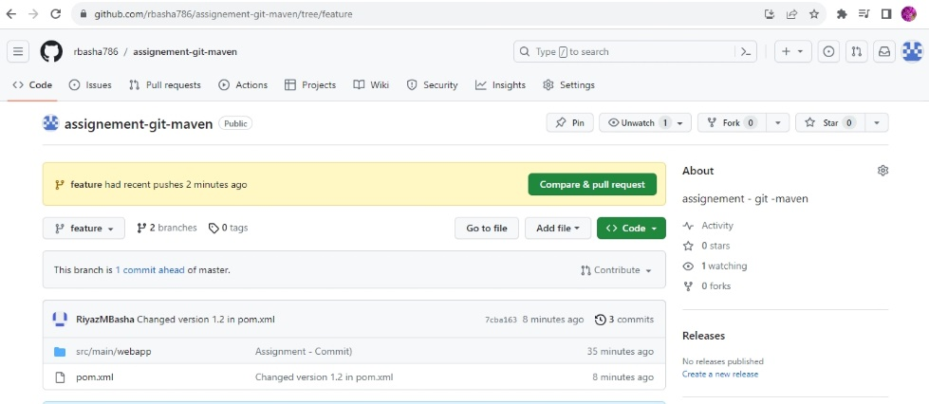

**10) Create full request and merge ‘feature’ branch changes to ‘main’ branch**

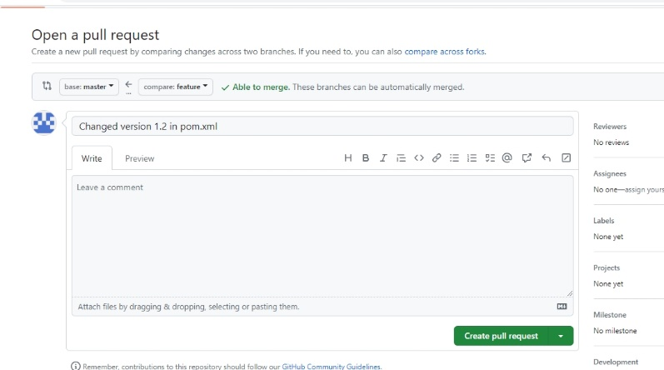

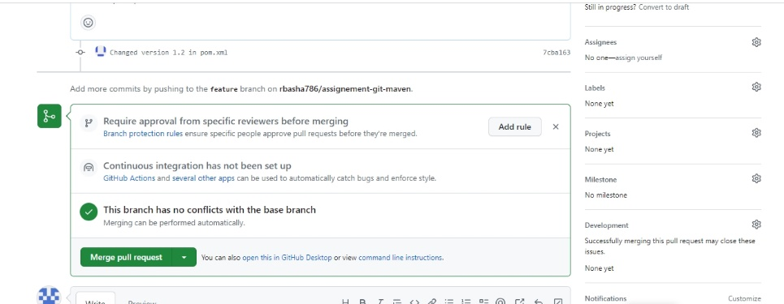

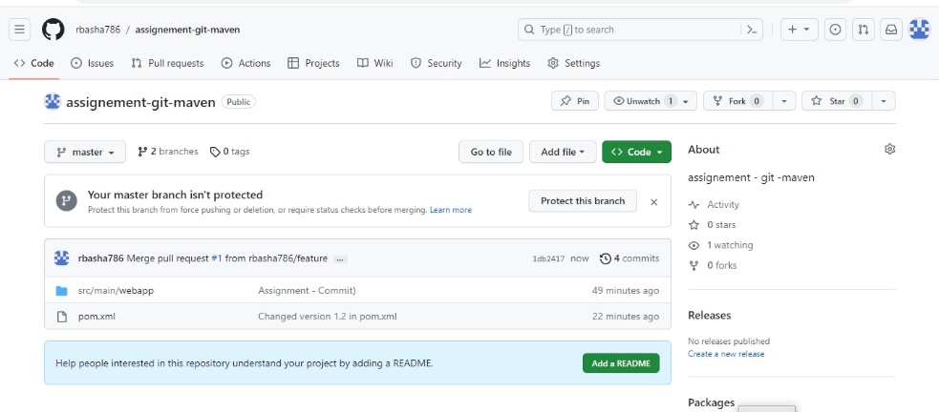

**Conclusion:** ***The assignment has been successfully committed.***